**Agile Project Document**

**Document 1: Definition of Done**

It is a crucial concept in Agile and Scrum methodologies. It defines the criteria or conditions that a product increment or a user story must meet to be considered complete and ready for release. The Definition of Done is agreed upon by the Scrum Team during the Sprint Planning or early in the project and is used as a guideline for the development team throughout the sprint.

The checklist for Definition of Done (DoD) :

**Acceptance Criteria:**

* **Functional Requirements:**
  + User can register and create an account.
  + User can login and access their profile.
  + User can view loan products and eligibility criteria.
  + User can complete an online loan application form (including land details, financial information, etc.).
  + The application can calculate loan eligibility based on defined rules.
  + The application can handle document uploads (e.g., land ownership documents, bank statements).
  + The system can integrate with relevant databases to verify user information.
  + The application provides users with a status update on their loan application.
* **Non-Functional Requirements:**
  + The application is accessible on mobile devices and web browsers.
  + The application interface is available in local languages (if applicable).

**Quality Criteria:**

* **Performance:**
  + The application loads quickly even on slow internet connections (common in rural areas).
  + The application can handle multiple users concurrently without performance issues.
* **Security:**
  + User data is encrypted and securely stored.
  + The application protects against common security vulnerabilities (e.g., SQL injection).
* **Usability:**
  + The application interface is user-friendly and easy to navigate for farmers with varying levels of technical expertise.
  + The application provides clear instructions and error messages.
* **Testing:**
  + Unit tests ensure individual functionalities work correctly.
  + Integration tests verify different parts of the application work together seamlessly.

**Document 2- Product Vision**





**Vision:  
 🡪** What is your vision, your overarching goal for creating the product?

The vision for creating an online agriculture loan application is to empower farmers with convenient access to financial resources, thereby fostering agricultural growth, resilience, and prosperity within rural communities. Our overarching goal is to leverage technology to streamline the lending process, increase financial inclusion, and support sustainable farming practices.

**Target Group**

* Which market segment does the product address?

The product targets the agricultural finance market segment, serving farmers, financial institutions, government agencies, agricultural cooperatives, agribusinesses, insurance providers, and rural development organizations.

* Who are the target users and customers?

The target users and customers include farmers, financial institutions, government agencies, agricultural cooperatives, agribusinesses, insurance providers, and rural development organizations.

**Needs**

* What problem does the product solve?

The product solves the problem of limited access to financial services for farmers by providing an online platform for convenient and accessible agricultural loans. It streamlines the loan application process, reduces paperwork, and facilitates faster approvals, thereby empowering farmers to access the capital they need to invest in their farms and improve productivity. Additionally, it enhances financial inclusion, promotes sustainable agriculture, and supports rural development initiatives.

* Which benefit does it provide?

The product provides the benefit of enhanced financial inclusion and accessibility to capital for farmers, leading to improved agricultural productivity, sustainability, and rural development.

**Product**

* What product is it?

The product is an online agriculture loan application platform.

* What makes it desirable and special?

The online agriculture loan application stands out for its convenience, efficiency, and focus on promoting financial inclusion and sustainable agriculture within rural communities.

* Is it feasible to develop the product?

Yes, it is feasible to develop the product, given the advancements in technology and the availability of resources and expertise in agricultural finance and software development.

**Value**

* How is the product going to benefit the company?

The product benefits the company by expanding its market reach, attracting new customers, and generating revenue through the sale of the online agriculture loan application platform. Additionally, it enhances the company's reputation as an innovator in agricultural finance technology and strengthens its position in the market.

* What are the business goals?

The business goals are to increase market share, revenue, and brand reputation while fostering partnerships, promoting financial inclusion, and achieving sustainable growth.

* What is the business model?

The business model involves offering an online agriculture loan application platform with revenue generated through subscription or transaction fees, alongside partnerships with government agencies, agricultural cooperatives, and agribusinesses.

**Document 3: User stories**















































































**Document 4: Agile PO Experience**

The Product Owner has a vision of the product keeping the domain/industry experience and

the market need.

* Following are the responsibilities of PO in a project

As a project owner with extensive domain and industry experience, I take on the following responsibilities to ensure the success of the product:

🡪Market Analysis:

* Conducting thorough market analysis to understand the needs and demands of the target audience.
* Evaluating the availability of similar products in the market to identify competitive advantages and gaps.

🡪Enterprise Analysis:

* Performing due diligence on the market opportunity to assess feasibility and potential impact.
* Analyzing market trends, industry regulations, and competitor strategies to inform decision-making.

🡪Product Vision and Roadmap:

* Developing a clear product vision that aligns with market needs and industry expertise.
* Creating a comprehensive product roadmap with high-level features and timelines to guide development efforts.

🡪Managing Product Features:

* Managing stakeholder expectations by effectively communicating the product vision and priorities.
* Prioritizing epics, stories, and features based on criticality, stakeholder needs, and return on investment.

🡪Managing Product Backlog:

* Prioritizing user stories and epics within the product backlog based on stakeholder feedback and business objectives.
* Reprioritizing backlog items as needed to respond to changing market conditions or project requirements.

🡪Managing Overall Iteration Progress:

* Conducting regular sprint progress reviews to monitor development progress and ensure alignment with project goals.
* Facilitating sprint retrospectives with the business analyst to identify areas for improvement and optimize project performance.

By leveraging my project owner experience and industry expertise, I ensure that the product meets market demands, delivers value to stakeholders, and achieves its strategic objectives.

* From this project I have learned how to handle sprint meetings such as

As a product owner with this valuable experience, I've honed my skills in effectively managing sprint meetings and creating user stories. Here's how this experience has enriched my role:

**🡪Sprint Meetings Management:**

* Sprint Planning Meeting: I can now efficiently plan upcoming sprints, selecting relevant user stories, and defining clear sprint goals to guide the team's work.
* Daily Scrum Meeting: I can facilitate daily stand-ups where team members share progress, addressing challenges, and aligning on priorities, ensuring everyone stays focused and informed.
* Sprint Review Meeting: I can conduct productive review sessions to showcase completed work, gathering feedback from stakeholders, and refining product direction based on insights gained.
* Sprint Retrospective Meeting: I can lead retrospectives to reflect on team performance, identifing areas for improvement, and implementing actionable changes to enhance future sprints.
* Backlog Refinement Meeting: I can collaborate with the team to regularly groom the backlog, refininging user stories, addinging details, and prioritizing items for upcoming sprints, ensuring the backlog remains well-managed and actionable.

**🡪User Stories Creation:**

* Story No: I can assign unique identifiers to user stories for tracking and reference, facilitating efficient communication and organization.
* Tasks: I can define clear tasks or activities required to complete each user story, breaking down work into manageable units and guiding the team's implementation efforts.
* Priority: I can prioritize user stories based on their importance, aligning with stakeholder needs, strategic objectives, and project timelines to maximize value delivery.
* Acceptance Criteria: I can articulate acceptance criteria that specify the conditions or criteria for each user story to be considered complete, ensuring clear expectations and quality standards.
* BV & CP Value: I can assess the business value and complexity of each user story, guiding prioritization efforts and resource allocation to optimize outcomes and mitigate risks effectively.

**Document 5: Product and sprint backlog and product and sprint burndown charts**

**Product backlog:**



**Sprint backlog:**



**Product burndown**

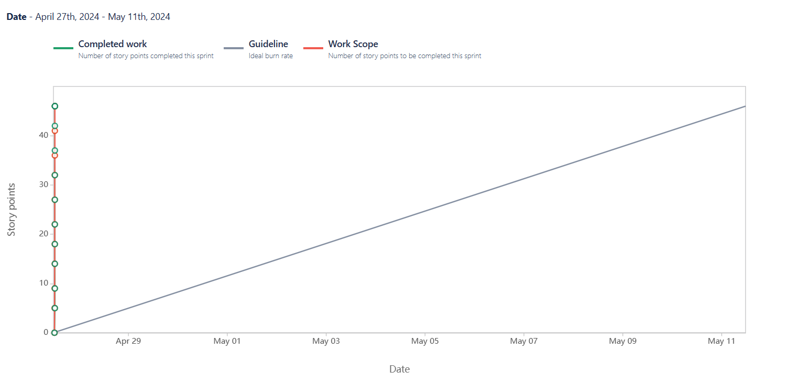

**Sprint burndown**

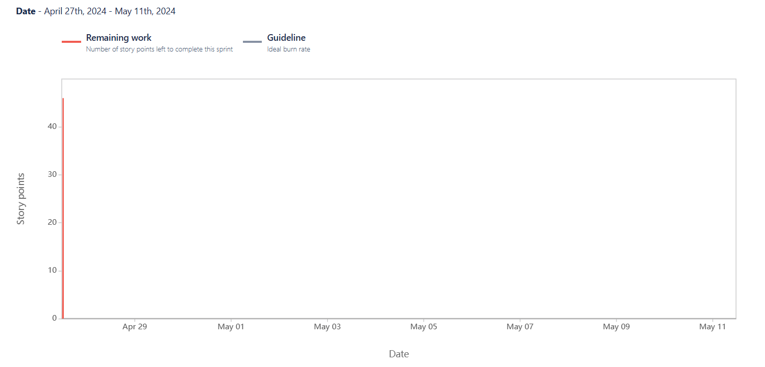

**Document 6: Sprint meetings**

**Sprint Planning Meeting**



**Agenda Topics**



**Other Information**



**Sprint review meeting**





**Sprint retrospective meeting**





**Daily Stand-up meeting**

